## Project Scopes And Limitations:

### Scope Statement

The main goal of this project is to develop and handover a fully functional online system for the client (**lorbek car showroom**) so that, **Lorbek car showroom** can manage different aspects of their business-like sales, Customer data, inventory, reporting, and financial transaction using the automated platform. After implementing this automated system there is possibility of increment in the efficiency, accuracy, and security along with user friendly environments.

**Scopes of the project are:**

1. To design System modules for Car Management, Credit Management, Booking Management, Customer Management, Payment Management, Insurance Management.
2. Creating Secure login systems for admin and Customer(users).
3. Features of Up-to-date reviews for motors, clients, bookings, bills, insurance, and loans.
4. Capability for reviews in PDF, Excel, and CSV formats.
5. Improved UI/UX design and capability for efficient facts access, validation, and retrieval.
6. Integration with outside offerings through restful APIs.
7. Adequate user education documentation.
8. Detailed facts storage for every vehicle, which include specs, guarantee info, and sales history.
9. Integration with stock management for real-time monitoring.

**Limitations of the project:**

1. The whole system is fully digital so before using the system, Reliable and effective training sessions for users need to be provided so that they can make effective use of the system and make them safe in digital world.
2. The system is online based so Reliable internet connection with Full Security is required for users. If there is any disturbance in internet connection it will directly affect the accessibility and functionality of the system
3. Whatever the data, users or customers give to the system. System will take them as correct except email, phone number. And provide reporting as per those data. For information and data reliability users need to give accurate and validated inputs to reduce issues in reporting and overall performance.
4. As technology is growing and new security threats are coming daily so clients need to match them with all the security tools and software to keep them safe in digital work. Only the security measures provided by the Auspal system are not sufficient.
5. There is an assumption that the project will complete with in budget but external features adding during the project might increase budget.
6. There could be situations where the users feel difficulties in integrating the online system of Lorbek car showroom with existing systems so seamless integration is Important for operational efficiency.

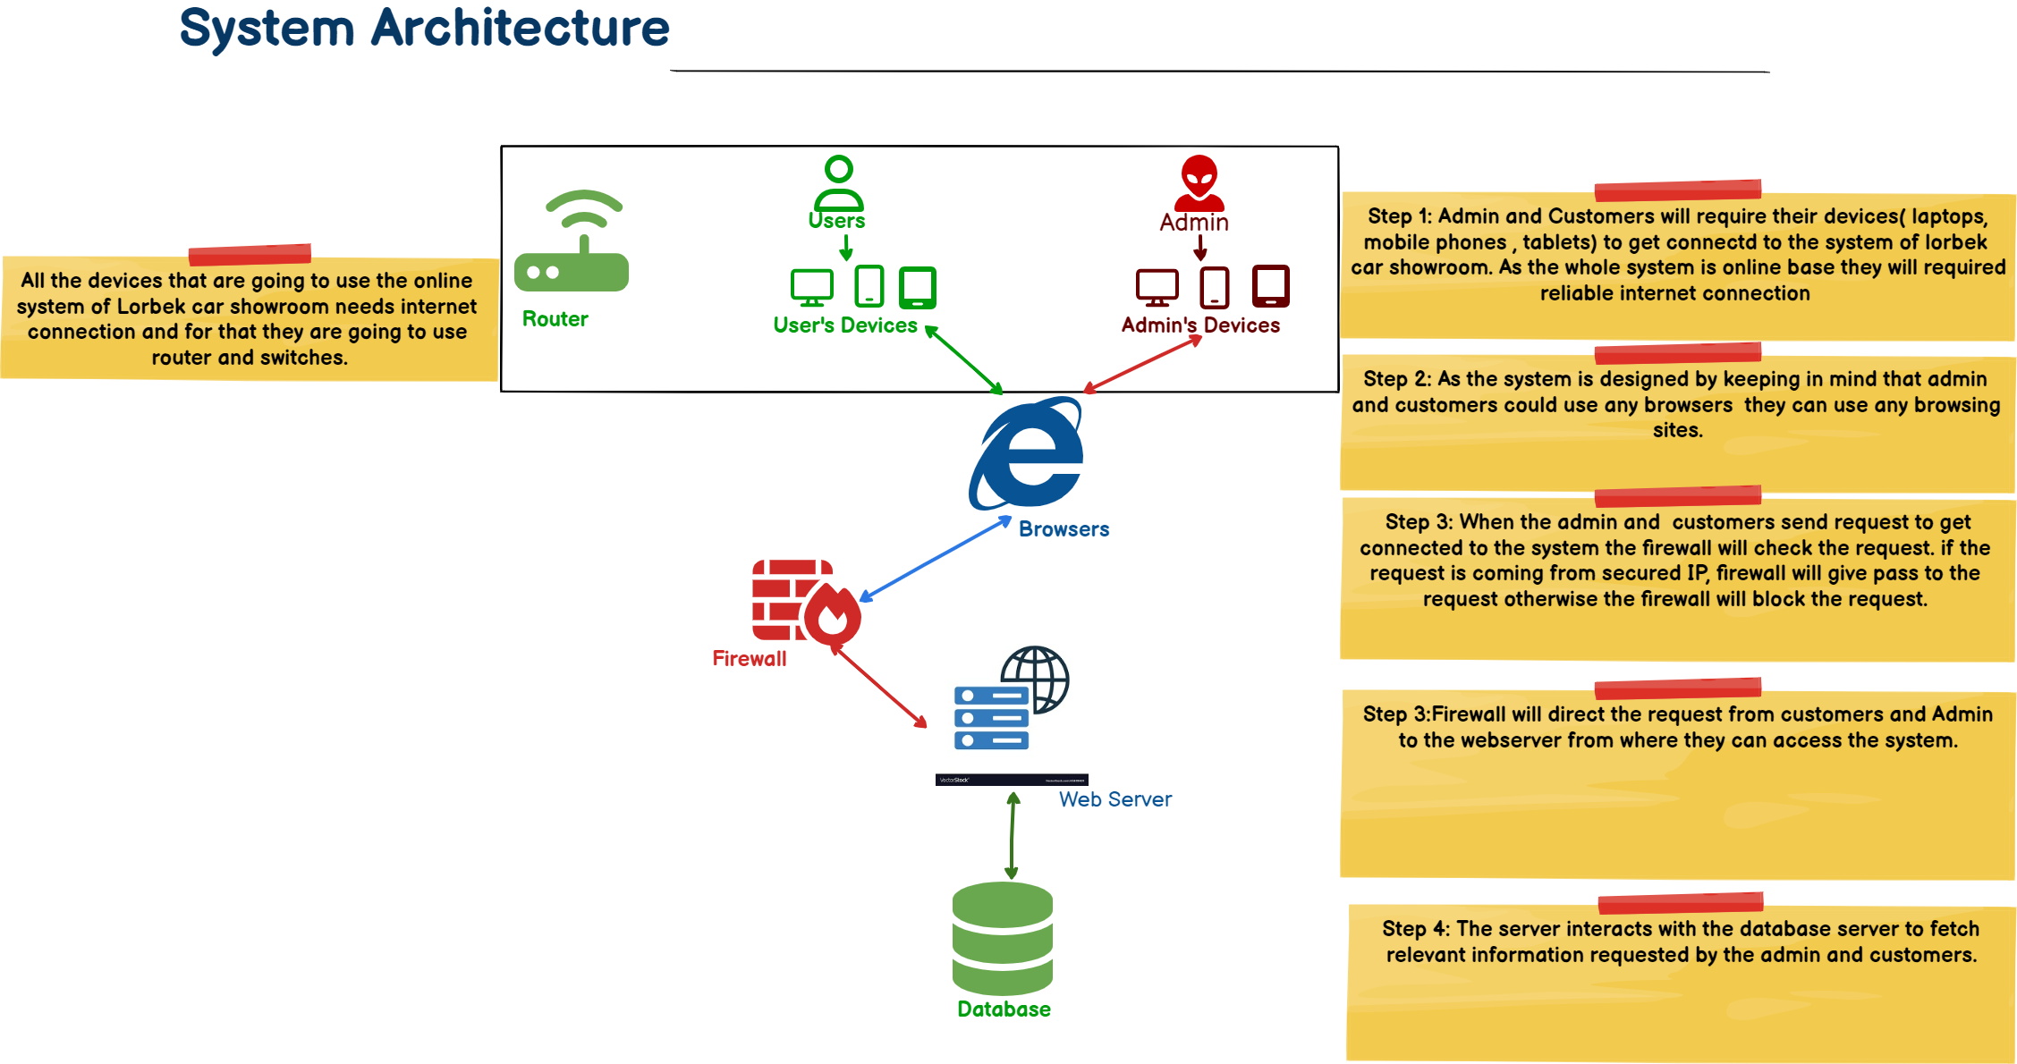

Fig: System Architecture

**Fig: Level 2 DFD Login**

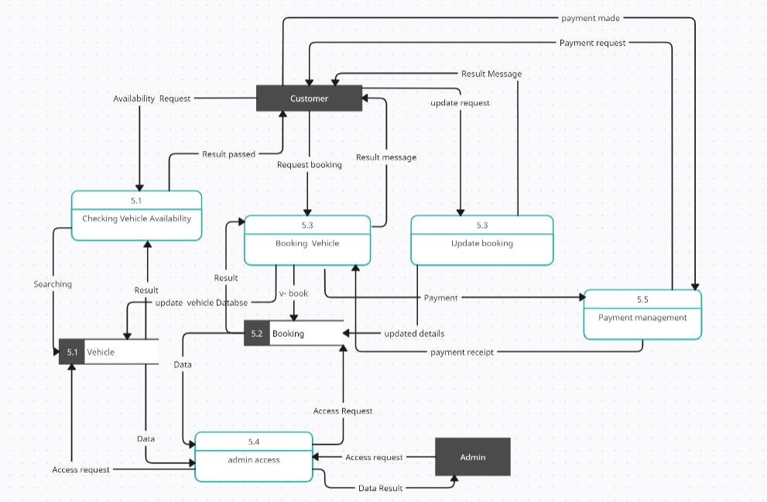

**Fig: level 2 DFD Booking**

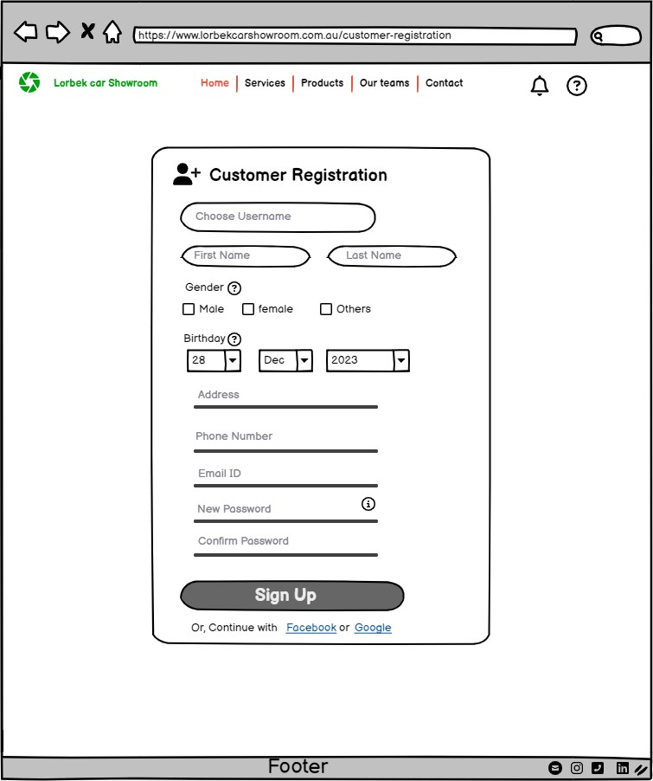

**Fig 1: Customer Registration.**

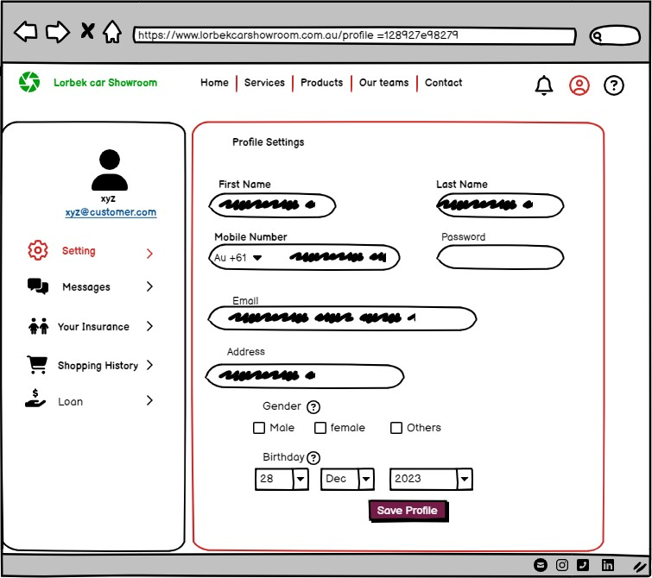

**Fig 2: Customer Dashboard**

**Fig 3: Customer Login**

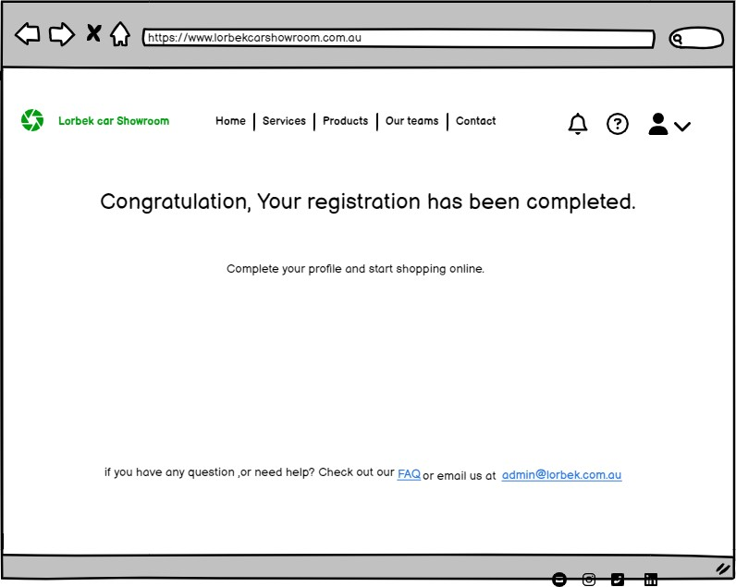

**Fig 4: Welcome message page for Customer**

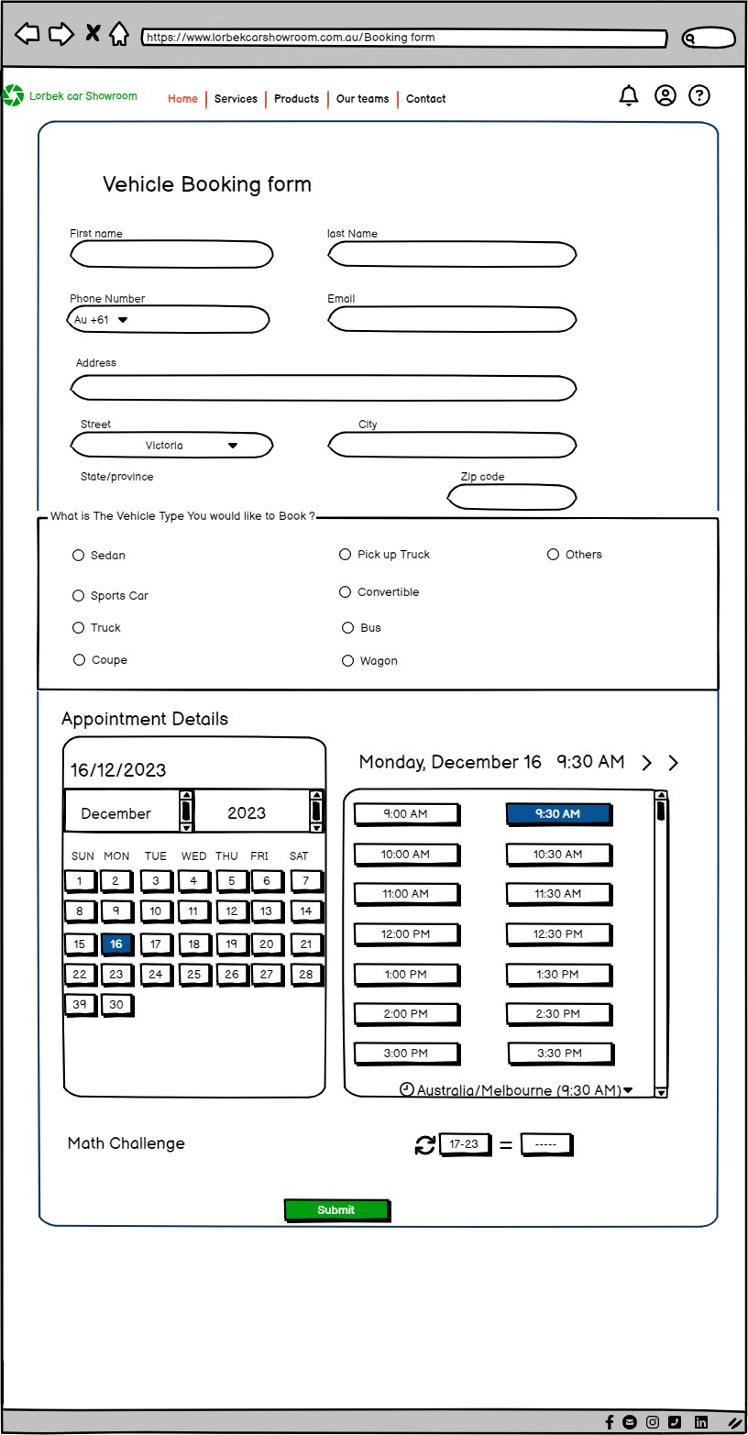Fig 5: Vehicle Booking form

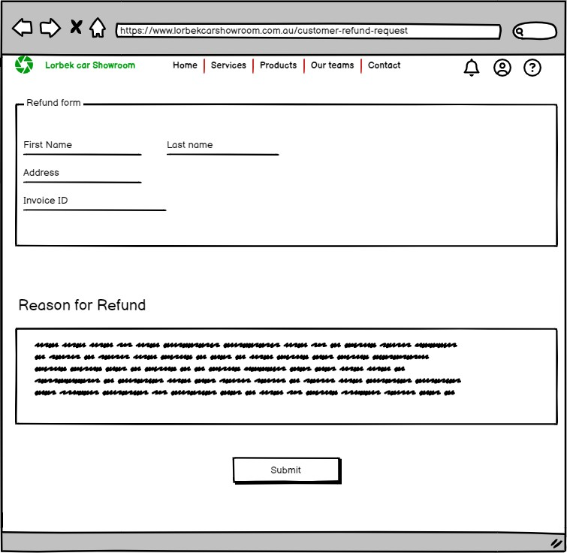

Fig 6: Refund Form

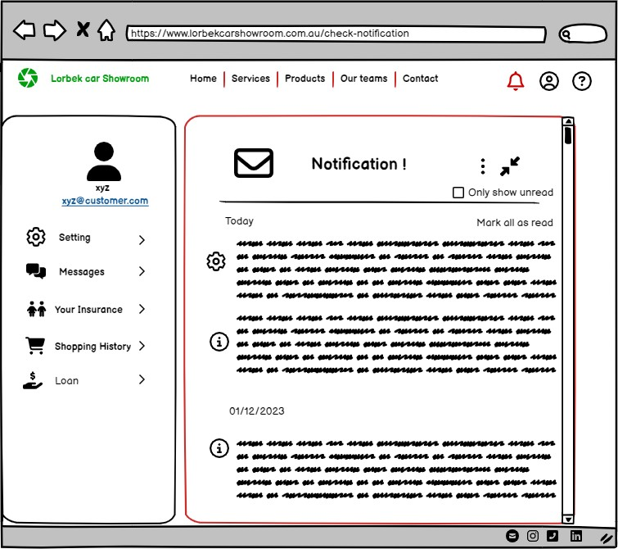

Fig 7: Notification page for Customer

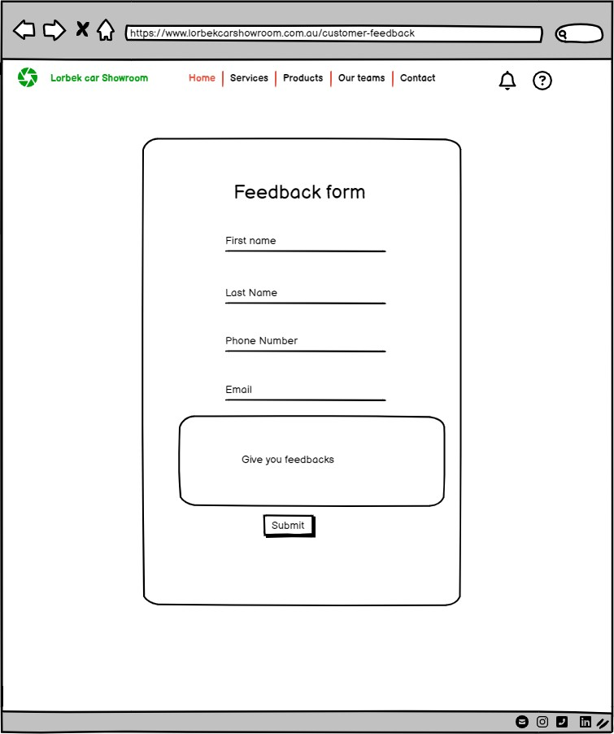

Fig 8: Customer Feedback Form

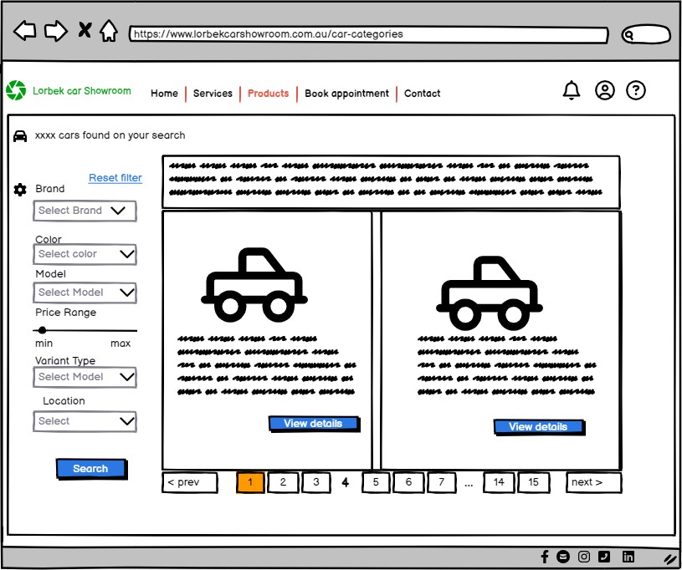

Fig 9: Car Categories page for Customer

Data protection Impact Assessment (DPIA)

## Needs for a DPIA

**Project Overview:**

Lorbek car showroom online System is designed as per the requirement given by Client. The whole system will simplify the management of Customers, cars, Booking, Financial Activities and any other types of queries coming from customer sides. This digital platform will also allow customers to create their private account and manage all their information like loans, bookings, Payments, and insurance. If the admin or Customer wants to export any information, they can do that in different formats like car/insurance/booking/payments in PDF, excel or CSV format,

User Interface (UI) of this system will be user friendly. Even the users with less digital system knowledge can surf in this system easily. For reducing the wrong input from the users, the system will try to validate inputs like phone number, email, address, and date of birth. If there is invalid values system will pass the message to users for valid input on those field and will not accept the input unless those errors are corrected. There will be two UI ends (customers & admin). Customers will have limited access, but the admin will have full access to the system.

DPIA is important for Lorbek Car showroom Online System because there will be personal data related to customers, Loans, payments and bookings and DPIA will make sure all those personal data are stored and managed securely by ensuring any legal compliance, identifying and mitigating possible risks, increasing security and developing privacy- conscious and responsible methods for the whole SDLC.

## Process Description

**Data Source:** There will be two sources from where data can be collected. Primary source is from Customers who give information into the system for creating Account, making booking, and choosing insurance. And second source is system itself as the system can also generate data internally during any transaction.

**Flowchart showing how data are collected, stored, and use in this system.**

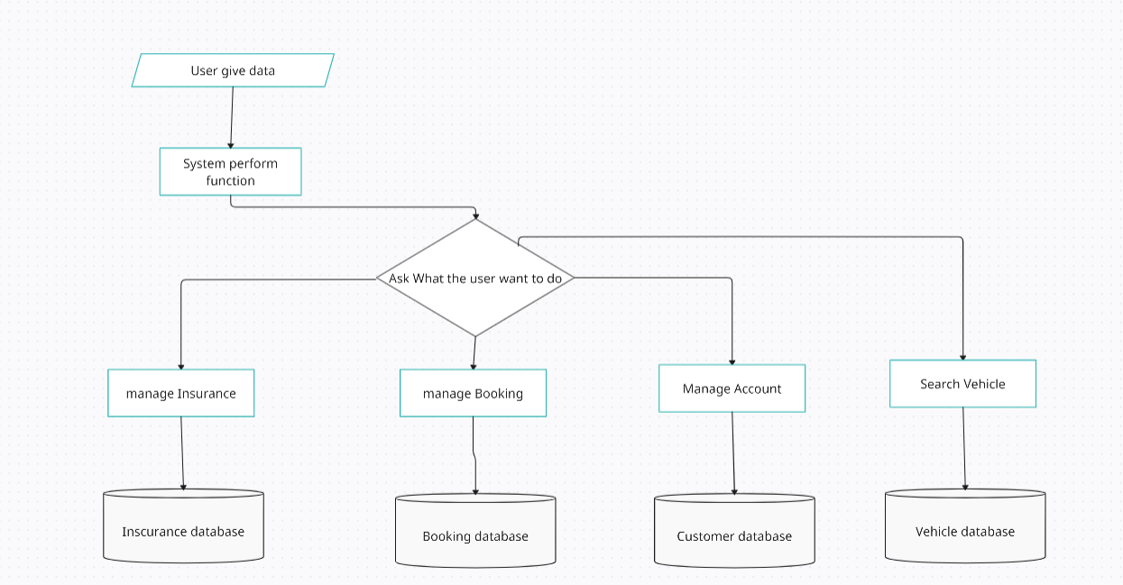

## Scope of Processing

**Nature of Data:** The Lorbek Car Showroom Online System deals with different data about cars, customers, payments, insurance, bookings, and loans. All the data in this system will be stored for longer period unless there is any Actions like Data deletion from the user or admin side of the system. All the data stored in the database of this system will be related to users of the system including some sensitive data. While collecting any data from the customers Lorbek car showroom needs to

## Consultation Process

For collecting any feedback or Reviews, the Lorbek Car Showroom system considers communicating with the relevant persons (Customers). It regulates when and how to ask individuals their thoughts on the system. The system also evaluates if it need assistance from other workers or whether it should seek the advice of information security specialists. It seeks to ensure that everyone who should be able to speak up has the chance to do so.

## Necessity and Proportionality

The Lorbek Car Showroom system Follows to the requirements to guarantee that everything inside the system is completed properly. It only handles data lawfully and for the sole purpose of managing business information. The system is designed to stay focused on its key goals and not stray from them. It monitors data to verify that it is correct and that it is not gathered in excess. People who use the system are aware that information about them is being collected. The technology also gives consumers control over their data and guarantees that everything is done legally to keep data safe, especially when it is transmitted to distant regions.

## Potential risk with Probability, severity, Risk Score &Priority level

|  |  |  |  |  |
| --- | --- | --- | --- | --- |
| Possible Risks in Lorbek Car showroom Online System | Probability  (1-5) | Impact  (1-5) | Risk Score  (probability * impact) | Priority level |
| Data Breaches | **4** | **5** | **20** | **high** |
| Inaccurate data due to human error or system glitches | **3** | **5** | **15** | **medium** |
| System crash out/ slowdown due to DDoS attack | **5** | **5** | **25** | **high** |
| Customer service failure | **4** | **4** | **16** | **high** |
| Technological Obsolescence | **3** | **4** | **12** | **medium** |

## Risk Mitigation methods with Effects Residual and Measure approved status.

|  |  |  |  |  |
| --- | --- | --- | --- | --- |
| Possible Risks in Lorbek Car showroom Online System | Mitigation Measures  (1-5) | Effect on risk5) | Residual risk | Measured Approved |
| Data Breaches | Regular security Audits and Vulnerability assessment along with using two-factor Authentication in Lorbek System. | Reduced | Low | Yes |
| Data inaccuracies | Implementing data validation and automated reconciliation processes in the input fields and providing training to users. | Reduced | medium | yes |
| DDoS Attacks | Using firewalls and setting the limitation of traffic to reach server. | accepted | medium | yes |
| Customer service failure | Gathering feedback from users and checking the issues reported by users. | Reduced | low | yes |
| Technological Obsolescence | Regular system updates and doing strategic planning for any possible new technology | Eliminated | High | yes |

|  |  |  |
| --- | --- | --- |
| **Item** | **Name/date** | **Notes** |
| Measures approved by: | Auspal Systems /14/12/2023 | Integration of Approved measures will apply Asap before 16/12/2023 |
| Residual risks approved by: | Santosh Thapa / 14/12/2023 | Ico Consultation needs to initiate for the high risks form the risk registers. |
| DPO advice provided: | Santosh Thapa /15/12/2023 | Comprehensive Advice is provided in table: Risk Mitigation methods with Effects Residual and Measure approved status. |
| Summary of DPO advice: For data protection of the customers DPO has suggested to use data validation measures along with better security and training to the persons using the systems. | |  |
| DPO advice accepted or overruled by: | Supervisor /16/12/2023 | DPO advices are accepted and Integrated in the Project plan. |
| Comments: Importance of DPO’s Guidance is acknowledged and followed to maintain data protection. | |  |
| Consultation responses reviewed by: | Stakeholders |  |
| Comments: Clear Descriptions is Documented. | |  |
| This DPIA will be kept under review by: | Santosh Thapa | The DPO should also review ongoing compliance with DPIA |

## Table: Signoff and Record Outcomes.